

DOMAIN WINTER CAMP

(*Department of Computer Science and Engineering*)

Name: Abhiroop Singh UID: 22BCS10352 Section: KPIT 901

**DAY 5**

**Ques 1. Given an integer k and array arr. Your task is to return the position of the first occurrence of k in the given array and if element k is not present in the array then return -1.**

**Program code:**

#include <iostream> #include <vector> using namespace std;

int findFirstOccurrence(int k, const vector<int>& arr) { for (int i = 0; i < arr.size(); i++) {

if (arr[i] == k) { return i + 1;

}

}

return -1;

}

int main() { int k = 16;

vector<int> arr = {9, 7, 16, 16, 4};

int result = findFirstOccurrence(k, arr); cout << result << endl; // Output: 3

return 0;

}

**Output:**

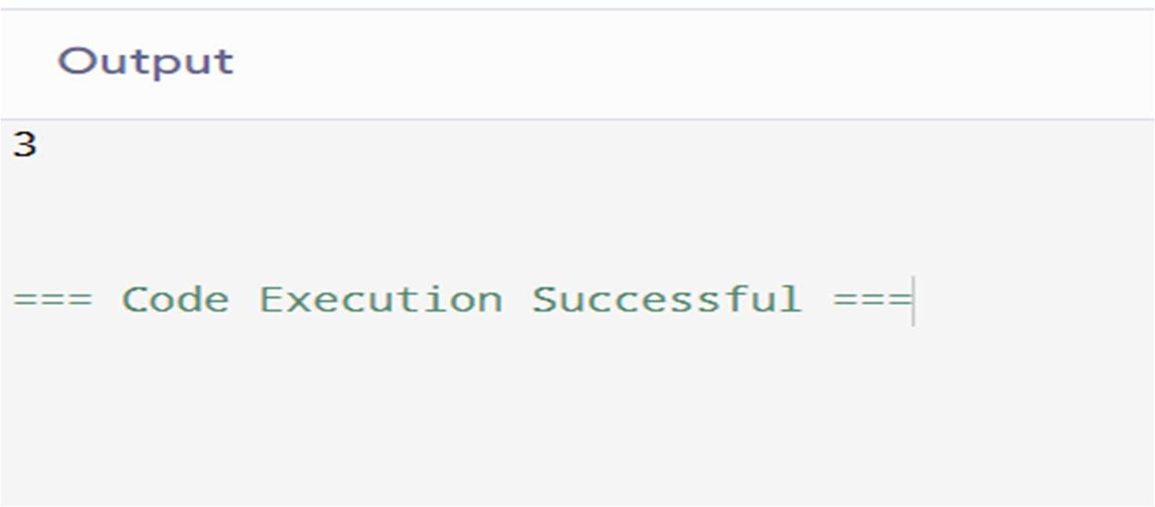

**Ques 2. Given an array of integers nums sorted in non-decreasing order, find the starting and ending position of a given target value.**

**If target is not found in the array, return [-1, -1].**

**You must write an algorithm with O(log n) runtime complexity.**

**Program code:**

#include <iostream> #include <vector> using namespace std;

vector<int> searchRange(const vector<int>& nums, int target) { auto findBound = [&](bool isFirst) -> int {

int left = 0, right = nums.size() - 1; int bound = -1;

while (left <= right) {

int mid = left + (right - left) / 2; if (nums[mid] == target) {

bound = mid; if (isFirst) {

right = mid - 1;

} else {

left = mid + 1;

}

} else if (nums[mid] < target) { left = mid + 1;

} else {

right = mid - 1;

}

}

return bound;

};

int start = findBound(true); int end = findBound(false); return {start, end};

}

int main() {

vector<int> nums = {5, 7, 7, 8, 8, 10}; int target = 8;

vector<int> result = searchRange(nums, target);

cout << "[" << result[0] << ", " << result[1] << "]" << endl; return 0;

}

**Output:**

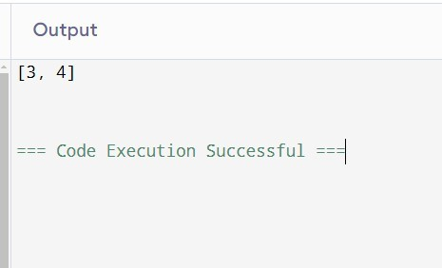

**Ques 3 You are given an integer array arr[]. Your task is to find the smallest positive number missing from the array.**

**Program Code:**

#include <iostream> #include <vector> using namespace std;

int findSmallestMissingPositive(vector<int>& arr) { int n = arr.size();

for (int i = 0; i < n; i++) {

while (arr[i] > 0 && arr[i] <= n && arr[arr[i] - 1] != arr[i]) { swap(arr[i], arr[arr[i] - 1]);

}

}

for (int i = 0; i < n; i++) {

if (arr[i] != i + 1) return i + 1;

}

return n + 1;

}

int main() {

vector<int> arr = {2, -3, 4, 1, 1, 7};

cout << findSmallestMissingPositive(arr) << endl; return 0;

}

**Output:**

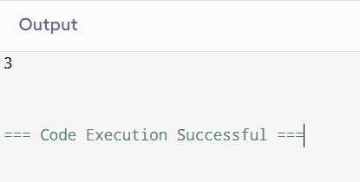

**Ques 4. You are given an m x n matrix mat that has its rows sorted in non- decreasing order and an integer k.**

**You are allowed to choose exactly one element from each row to form an array.**

**Return the kth smallest array sum among all possible arrays.**

**Program Code:**

#include <iostream> #include <vector> #include <queue> using namespace std;

int kthSmallest(vector<vector<int>>& mat, int k) {

priority_queue<int, vector<int>, greater<>> minHeap; minHeap.push(0);

for (const auto& row : mat) {

priority_queue<int, vector<int>, greater<>> nextHeap; while (!minHeap.empty()) {

int sum = minHeap.top(); minHeap.pop();

for (int num : row) { nextHeap.push(sum + num);

if (nextHeap.size() > k) nextHeap.pop();

}

}

minHeap.swap(nextHeap);

}

return minHeap.top();

}

int main() {

vector<vector<int>> mat = {{1, 3, 11}, {2, 4, 6}}; int k = 5;

cout << kthSmallest(mat, k) << endl; return 0;

}

**Output:**

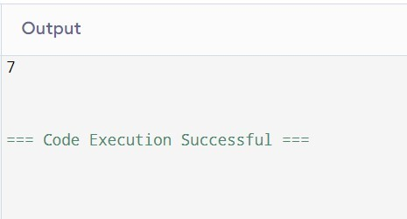

**Ques 5. You are given an array of k linked-lists lists, each linked-list is sorted in ascending order.**

**Merge all the linked-lists into one sorted linked-list and return it.**

**Program Code:**

#include <iostream> #include <vector> #include <queue> using namespace std; struct ListNode {

int val; ListNode* next;

ListNode() : val(0), next(nullptr) {} ListNode(int x) : val(x), next(nullptr) {}

ListNode(int x, ListNode* next) : val(x), next(next) {}

};

class Solution { public:

ListNode* mergeKLists(vector<ListNode*>& lists) {

auto compare = [](ListNode* a, ListNode* b) { return a->val > b->val; }; priority_queue<ListNode*, vector<ListNode*>, decltype(compare)>

minHeap(compare);

for (ListNode* list : lists) {

if (list) minHeap.push(list);

}

ListNode dummy(0); ListNode* current = &dummy; while (!minHeap.empty()) {

ListNode* node = minHeap.top(); minHeap.pop();

current->next = node; current = current->next;

if (node->next) minHeap.push(node->next);

}

return dummy.next;

}

};

int main() {

ListNode* l1 = new ListNode(1, new ListNode(4, new ListNode(5))); ListNode* l2 = new ListNode(1, new ListNode(3, new ListNode(4))); ListNode* l3 = new ListNode(2, new ListNode(6)); vector<ListNode*> lists = {l1, l2, l3};

Solution solution;

ListNode* result = solution.mergeKLists(lists);

while (result) {

cout << result->val << " "; result = result->next;

}

return 0;

}

**Output:**

